2024 Mandarin, Culture Study & Island Tour Taiwan
(14th annual summer program since 2009)
交換學生中文學習營與環島觀光

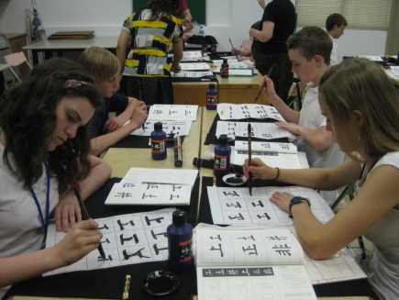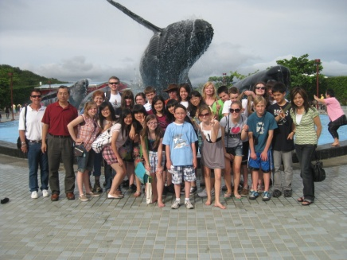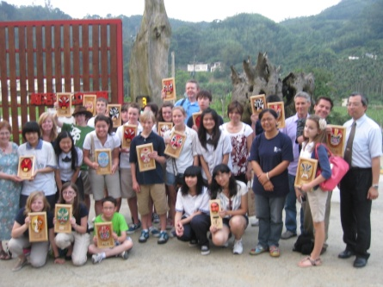
Mandarin Chinese Study & Island Tour in Taiwan
Date: May 23rd to June 6th 2024

Taiwan is beautiful island with amazing food. It faces the Pacific Ocean, with Japan's Ryukyu Islands not far away. Taiwan possesses an endless variety of terrain, forests, agricultural products, and marine ecologies, as well as a diversity of ethnic cultures along with enchanting human customs and steeped in Chinese culture and tradition.
Over 7.6 billion people speak Mandarin Chinese. It is the second most spoken language in the world. Learning Chinese is a great investment and one of the best languages to learn. Many international companies and government diplomats are looking for job applicants who can speak more than one language, particularly Chinese, and you could be one of them!‍ If you want to better understand Chinese culture, language and explore the traditional heritage in a friendly place, Taiwan is an ideal choice. Taiwan has been home to numerous world-renowned Mandarin Chinese language institutions. This is one of the reasons why thousands of international students come to Taiwan for all levels of language study every year.
Taiwan produces a huge percentage of the world’s computer components, Acer and Asus are two of the world leaders in laptop production. Taiwan is also home to Computex, one of the world’s largest computer and IT trade fairs. TSMC is another world's most valuable semiconductor company. Taiwan is home to both Merida and Giant Bicycle manufacturers. Giant is accepted as the world’s largest bike manufacturer while Merida sells their bikes in 77 countries. Taiwan also creator of the world-famous bubble drink that is getting all the attention. This relatively new drink (it was invented in the ’80s but only “discovered” by the rest of the world recently) is fast becoming a favorite all over the world, and it all started right here in Taiwan. Taiwan is a free and democratic country, ranking as the second-freest country in Asia and seventh in the world according to Freedom House’s latest report on global freedom in 2023. Taiwan has beautiful scenery and friendly people. It is home to amazing national parks that scenic beaches, mountains, valleys, and even dormant volcanoes. Taiwan has such natural beauty that several major film productions such as 'Silence' and 'Life of Pi' took advantage of its scenery.
There is a Chinese saying: “Seeing is believing. Traveling ten thousand miles is better than reading ten thousand books.” Let’s explore this beautiful island together in May 2024.
Summary
The itinerary includes culture and language study and island tour held by Taiwan High School, coordinated by Utah Chinese School which will provide American students with both quality language classes and a taste of authentic Chinese lifestyles. It also offers valuable language immersion and cultural exposure and experience. The curriculum includes Mandarin Classes and Cultural Workshops such as martial arts, Chinese cooking, Dragon Dance, Chinese Knot Tying, and Traditional Chinese Painting and Calligraphy. You will also experience the best of Taiwan island tour and food. Nowhere will international students find a better place to experience and learn about Chinese culture and see the beautiful island of Taiwan. It’s an adventure of a lifetime!

Program Completion:
Each student will be awarded a Language & Culture Study Completion Certificate at the end of the program.
Fees:
Program Fees: US$ 3,990. This fee includes air fare (round trip SLC-TPE), ground transportation from and to Taoyuan airport, on-island tour expenses, tickets to tourist attractions, bus transportation, hotels and meals, driver tips, host families’ accommodations and meals, Mandarin Chinese study workshops, tuition, and text materials. The program will go forward only if the requisite number of students sign up.

Accommodation:
Host Families:
Students will enjoy a loving and caring host families carefully select by Taiwan High School Director to make sure families meet the criteria of the quality care, safety, and comfort. Students will experience the culture, customs, society, traditions, and family life while enjoying the hospitality and warmth of home stay. It will enrich your educational journey and elevate your study abroad experience.

Hotel:
When traveling around the island, students and teachers will stay in a comfortable, elegant, and secure hotel. There will be 3-4 teachers & chaperons who will monitor the students daily.

Itinerary
Day 1-2 Arrive in Taipei.
Chiang Kai-Shek Memorial Hall/Taipei 101

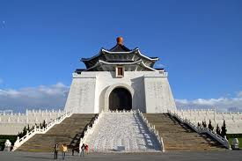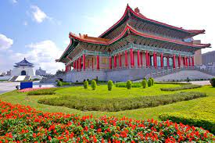
Chiang Kai-shek Memorial Hall （中正紀念堂/自由廣場）
Chiang Kai-shek Memorial Hall is a national monument, landmark and tourist attraction erected in memory of Chiang Kai-shek, former President of Taiwan. This popular attraction, set within a 62-acre (25-hectare) beautiful memorial park with gardens, ponds, and walkways. Inside the cavernous hall is an artefact museum with Chiang's two Cadillacs, various history documents and articles from daily life. The hourly changing of the honour guard is probably the most popular sight with most visitors.

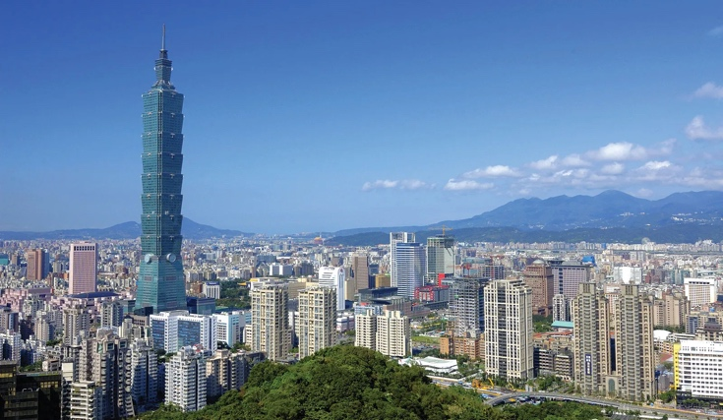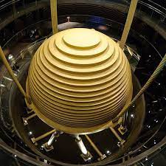
Taipei 101 （台北101）
Taipei 101 was officially classified as the world's tallest from its opening in 2004 until the 2009 completion of the Burj Khalifa in Dubai, UAE. Awarded a Leadership in Energy and Environmental Design (LEED) Platinum certification for its design and energy efficiency. A giant steel ball that sways like a pendulum to counterbalance earthquakes and typhoons. Inside the tower houses offices, restaurants, shops, and indoor and outdoor observatories. The tower is adjoined by a multilevel shopping mall that has the world's largest ruyi symbol as an exterior feature.

Day 2:
Why is Taiwan the top chip manufacturer? Why is TSMC so good at making chips? Inside the Taiwan Firm That Makes the World's Tech Run
Visit TSMC Innovation Museum
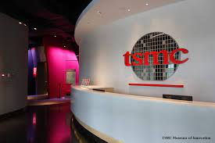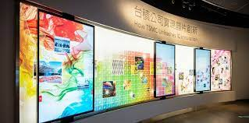
TSMC is the world's largest contract chipmaker, ranked as the largest invention patent applicant in Taiwan for the fourth consecutive year in 2022, according to the Ministry of Economic Affairs (MOEA). In 2022, Taiwan received 50,242 invention patent applications, up 2.3 percent from a year earlier with the semiconductor industry as the top applicant. TSMC produces about 90% of high-performance chips across the globe. Also, it controls over 50% of the global semiconductor foundry market in terms of revenue.

Day 4-8, 10-13 Mandarin Chinese & Culture study
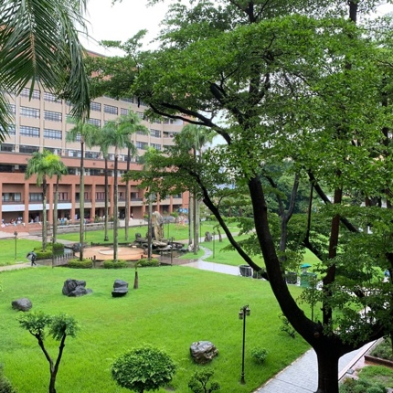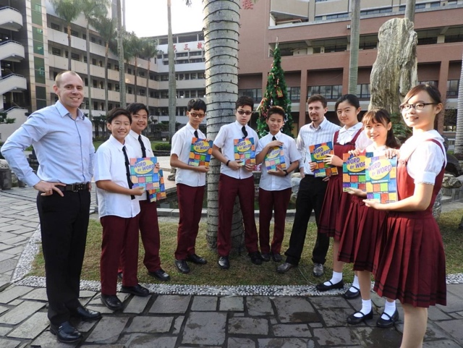
Taiwan high school is very reputable high-quality school. The principal, teachers and students are energetics, artistic and friendly. They continue pursuit of excellence, innovation, and fulfillment of superior education.
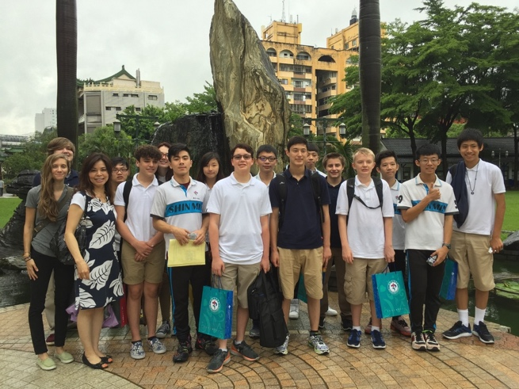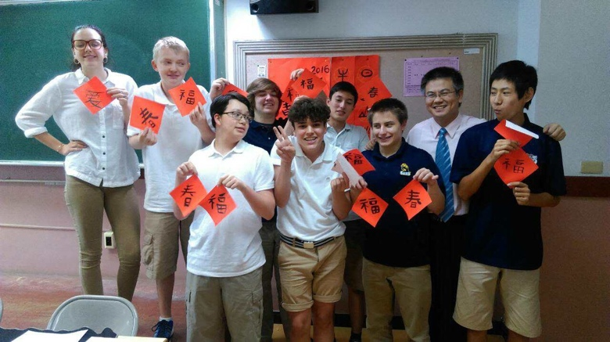
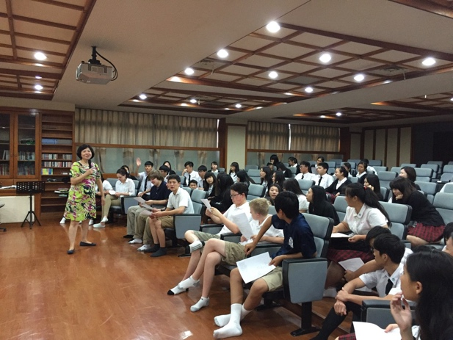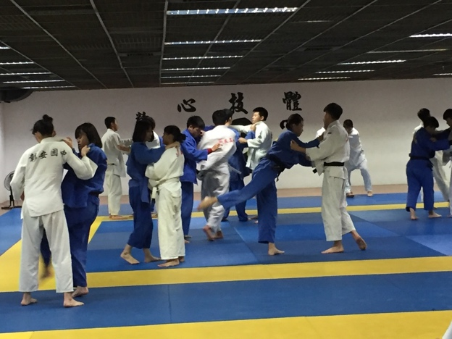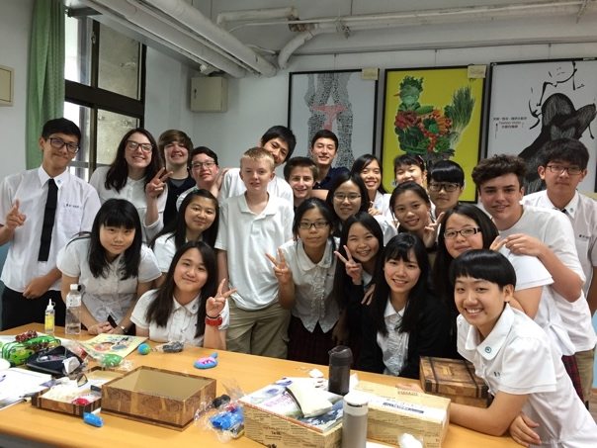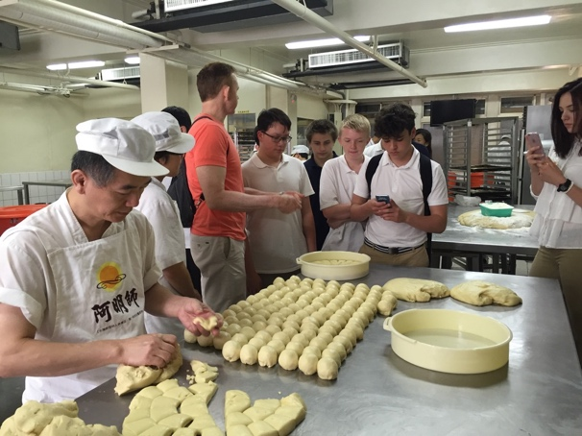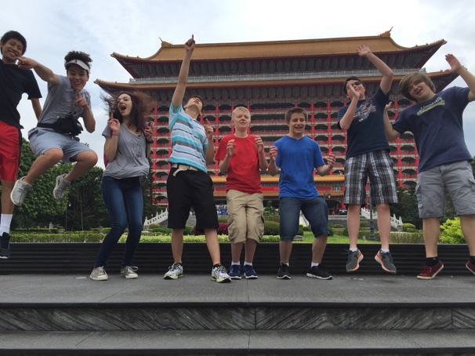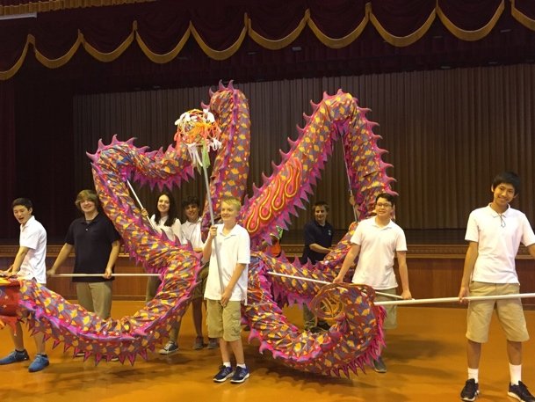
Mandarin Classes and Cultural Workshops such as Martial arts, Chinese cooking, Dragon Dance, Chinese Knot Tying, and Traditional Chinese Painting and Calligraphy.

Weekend Tour: Kaohsiung Fo Guang Shan Buddha Museum/Zhuo Ying- Lotus Pond and Tiger Pagodas
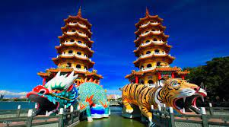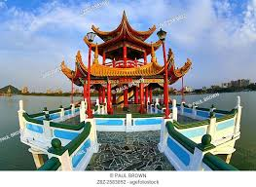

Impressive colourful pagoda at the beautiful Lotus Pond. The most notable feature of this location is its entrance and exit concept, which is reminiscent of a tiger's mouth and a dragon's throat. This structure's symbolic meaning is turning back bad fortune and entering into a good one. As the dragon and tiger govern the elemental forces of wind and rain, they were revered as rulers of the cosmos and the natural world. Their symbolic pairing was believed to bring about the blessings of rain and peace. The flying dragon and prowling tiger also came to represent heaven and earth. Inside, paintings depict China's 24 most obedient sons as well as scenes of heaven and hell to inspire people to do good deeds during their lifetime, and to provide threatening examples of retribution for wrongdoing.

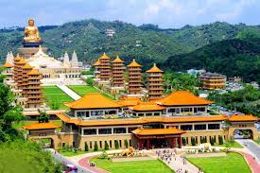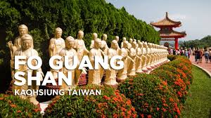
Fo Guang Shan Buddha Museum （佛光山）
Fo Guang Shan is the largest Buddhist temple in Taiwan and is home to the largest bronze sitting Buddha statue in Southeast Asia. Fo Guang Shan's galleries display a variety of Buddhist historical and cultural objects from around the world, including poetry, calligraphy, religious ...

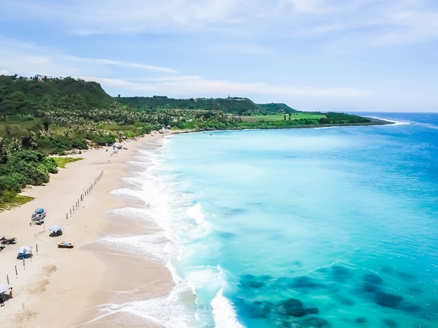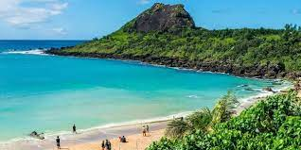
Kenting (墾丁)
Situated at the southern tip of Taiwan in Pingtung County, Kenting is the island's premier beach destination and a huge must on any Taiwan itinerary. With white sandy beaches, turquoise water, lush tropical forests, stretched-out seaside cliffs and a bustling night market, Kenting has a lot going for it!Kenting is a tropical paradise which has warm weather throughout the year. The average temperature does not go below 19 degrees, even in December.

Registration:

- 2024 program now is open to register through December 30th, 2023.
- Please fill out the registration form and medical form for students participating in Taiwan study and tour program.
- Deposit fee $500 (nonrefundable once the airline ticket is booked, it will apply towards the tuition.) If you have any questions, please email at utahchineseschool@gmail.com

